Lawful Transformational Substrate Architectures and Recursive Admissibility-Preserving Computational Systems
Layer 1 Provisional Patent

Field of the Invention
The present disclosure relates generally to:
- computational architectures,
- artificial intelligence systems,
- representation systems,
- recursive indexing systems,
- recursive traversal systems,
- world-model architectures,
- recursive planning systems,
- graph systems,
- biological modeling systems,
- recursive geometry systems,
- and transformation-preserving computational infrastructures.
More specifically, the disclosure relates to:
- lawful transformational substrates,
- admissibility-preserving computation,
- recursive operational structure,
- recursive traversal-preserving representations,
- recursive admissibility propagation,
- recursively constrained computational systems,
- substrate-induced geometry,
- recursive neighborhood-generation systems,
- recursive transformational continuity systems,
- and recursively organized lawful transformation architectures.
The disclosed systems may operate within:
- symbolic systems,
- graph systems,
- geometric systems,
- manifold systems,
- biological systems,
- latent-space systems,
- world-model systems,
- planning systems,
- robotics systems,
- simulation systems,
- transfer-learning systems,
- reinforcement-learning systems,
- multi-agent systems,
- distributed systems,
- or recursively organized computational substrates.
Although certain embodiments described herein reference biological systems, the disclosed transformational substrate architectures are not limited to biological implementations and may operate over computational, symbolic, geometric, planning, robotic, simulation, world-model, graph-based, or recursively organized operational substrates.

Background of the Invention
Conventional computational and artificial intelligence systems typically treat representations as primary computational primitives.
In many existing systems:
- symbols are indexed statically,
- relational structure is reconstructed statistically,
- embeddings are optimized after representation generation,
- and transformation validity is not explicitly preserved across computational scales.
Similarly, many contemporary machine-learning architectures:
- optimize latent similarity,
- preserve statistical consistency,
- or stabilize representations through predictive or self-supervised learning objectives,
while failing to explicitly preserve lawful traversal structure, recursive operational continuity, or admissible transformation geometry.
As computational systems scale:
- independently learnable relationships increase rapidly,
- traversal spaces become combinatorially large,
- representations become unstable under abstraction,
- transfer learning becomes unreliable,
- and optimization increasingly explores invalid or operationally incoherent state regions.
Many existing systems further assume that:
- geometric proximity implies operational similarity,
- statistical similarity implies transfer compatibility,
- or latent-space continuity implies lawful transformational continuity.
However:
- nearby states may remain operationally incompatible,
- statistically similar representations may violate lawful traversal structure,
- and latent continuity may fail to preserve admissible transformations.
Existing graph, embedding, and manifold-learning systems frequently:
- lose reachability structure during abstraction,
- destroy meaningful traversal continuity,
- fail to preserve recursive operational relationships,
- or collapse lawful neighborhood structure during optimization.
Likewise, conventional compression and coarsening systems often:
- reduce dimensionality without preserving operational continuity,
- compress states while destroying lawful traversal pathways,
- or fail to preserve admissible transformation structure across abstraction scales.
Accordingly, there exists a need for computational systems capable of:
- preserving lawful transformational structure,
- recursively propagating operationally admissible relationships,
- preserving lawful traversal continuity,
- recursively organizing admissible neighborhoods,
- preserving recursive reachability,
- and inducing stable operational geometry prior to statistical learning.
There further exists a need for systems in which:
- operational structure remains computationally active across recursive scales,
- recursively preserved admissibility constrains future computation,
- and lawful traversal structure governs representation formation, planning, transfer, abstraction, and inference.

Core Architectural Thesis
The present disclosure introduces lawful transformational substrate architectures in which:
- admissible transformations define lawful traversal structure,
- recursively preserved operational structure constrains future computation,
- recursively organized neighborhoods induce higher-order lawful geometry,
- and scalable computation emerges from recursively preserved admissibility relationships operating over bounded transformational substrates.
Unlike conventional systems that treat representations as relatively unconstrained statistical objects, the disclosed architectures:
- preserve lawful transformational continuity,
- recursively preserve admissible traversal structure,
- preserve operational reachability relationships,
- recursively organize lawful neighborhoods,
- and induce stable traversal geometry from substrate-defined admissibility systems.
In various embodiments:
- recursive indexing operates over lawful transformational substrates,
- recursively generated neighborhoods preserve admissible transformations,
- recursively preserved operational structure constrains future traversal,
- and recursively organized geometry preserves lawful computation across abstraction scales.
In some embodiments:
- recursively preserved structure remains operationally active during later computational stages,
- recursively organized admissibility systems constrain planning and inference,
- and recursive traversal continuity preserves meaningful operational relationships across recursive abstraction levels.

Summary of the Invention
The present disclosure provides systems and methods for:
- lawful transformational substrate architectures,
- recursive admissibility-preserving computation,
- recursive traversal-preserving representation systems,
- recursively organized operational geometry,
- recursive neighborhood-induction systems,
- recursive transformational continuity systems,
- and recursively constrained computational infrastructures.
In various embodiments:
- computation proceeds through lawful traversal of admissible transformations,
- recursively preserved operational structure constrains future transformations,
- recursively generated neighborhoods induce higher-order lawful geometry,
- and recursively organized admissibility systems preserve operational continuity across abstraction scales.
In some embodiments:
- recursively organized transformational substrates define lawful neighborhood structure before learning begins,
- recursive indexing preserves admissible traversal pathways,
- recursively generated operational geometry constrains representation formation,
- and recursively organized traversal systems preserve lawful reachability relationships.
Unlike conventional representation-learning systems:
- representations are not treated as primary computational primitives,
- latent similarity alone does not determine operational compatibility,
- and lawful transformational continuity governs recursive organization and traversal.
In various embodiments:
- recursively preserved admissibility structure reduces independently learnable relationships,
- recursively organized lawful neighborhoods reduce invalid traversal exploration,
- recursively induced geometry preserves operational reachability,
- and recursively constrained traversal systems improve transfer stability, planning consistency, abstraction coherence, and computational scalability.
The disclosed systems may operate over:
- symbolic substrates,
- graph substrates,
- sphere-based substrates,
- recursive relational substrates,
- manifold systems,
- biological systems,
- recursive planning systems,
- world-model architectures,
- latent traversal systems,
- or recursively organized operational state spaces.
In various embodiments, biological systems comprise illustrative embodiments of lawful transformational organization; however, the disclosed systems are not limited to biological domains and may operate across substantially different adaptive, computational, or operational infrastructures.

Figure Descriptions

Figure 1 — Recursive Representation Substrate Architecture
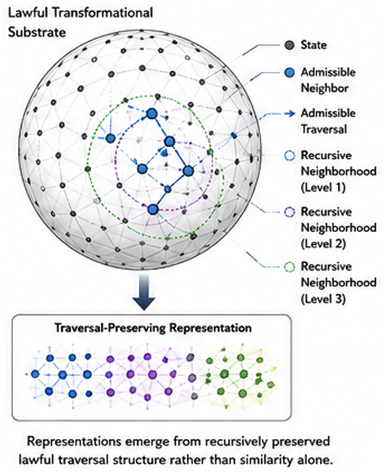
Figure 1 illustrates a lawful transformational substrate architecture in which:
- admissible transformations define lawful neighborhood structure,
- recursive indexing preserves lawful traversal pathways,
- recursively generated neighborhoods induce higher-order operational geometry,
- and recursively preserved operational structure constrains future computation.
In some embodiments:
- recursively organized neighborhoods generate recursively admissible traversal systems,
- recursively induced geometry preserves lawful reachability,
- and recursive admissibility propagation preserves operational continuity across abstraction scales.

Figure 2 — Admissibility-Preserving Traversal System
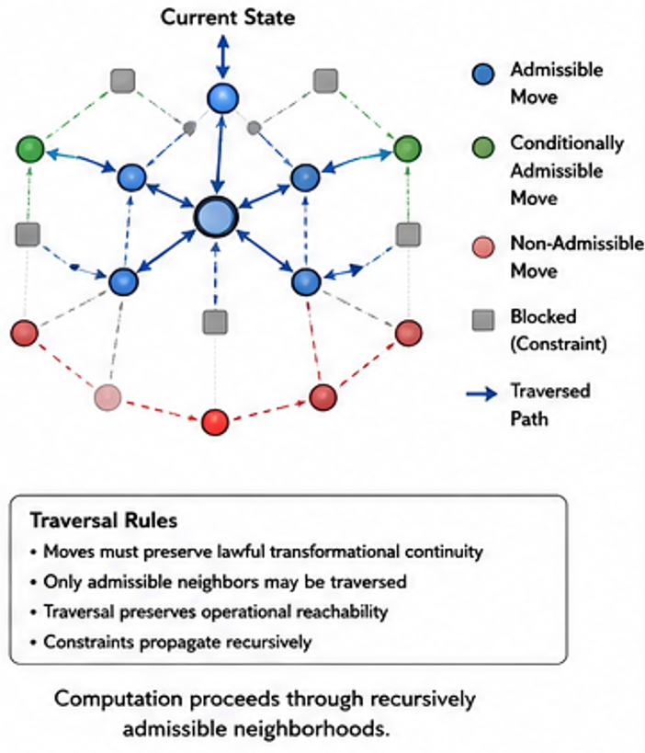
Figure 2 illustrates lawful traversal through recursively admissible neighborhoods.
In some embodiments:
- admissible transformations preserve operational continuity,
- recursively preserved traversal systems maintain lawful reachability,
- and recursively constrained traversal prevents operationally invalid transitions.
Figure 2 may illustrate:
- lawful traversal pathways,
- admissibility boundaries,
- recursively generated neighborhoods,
- operational geodesics,
- or recursively preserved traversal continuity.

Figure 3 — Recursive Operational Structure Preservation
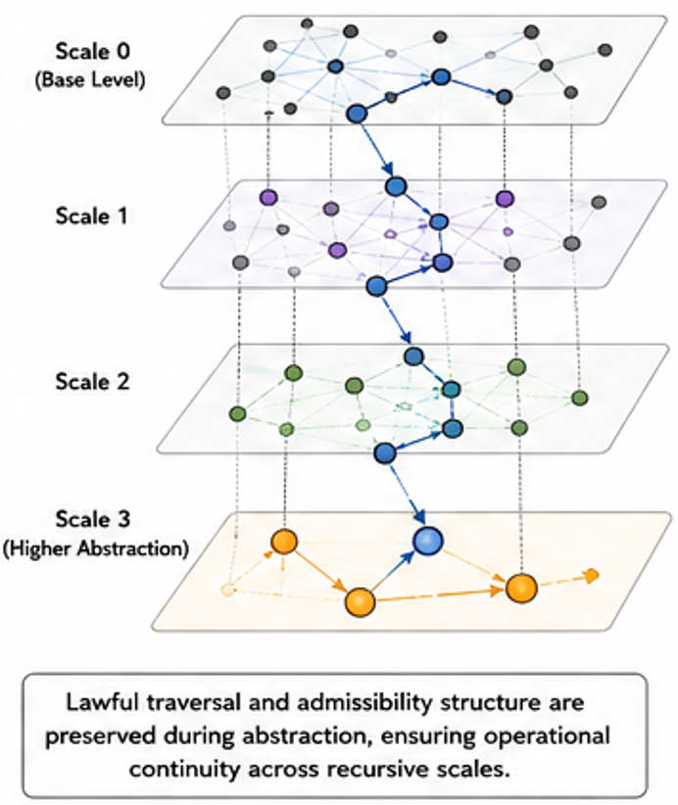
Figure 3 illustrates recursive preservation of operational structure across recursive abstraction levels.
In some embodiments:
- preserved lawful structure remains computationally active during later recursive stages,
- recursively organized neighborhoods preserve operational continuity,
- and recursively induced geometry preserves lawful reachability across scales.

Figure 4 — Transformational Substrate Comparison
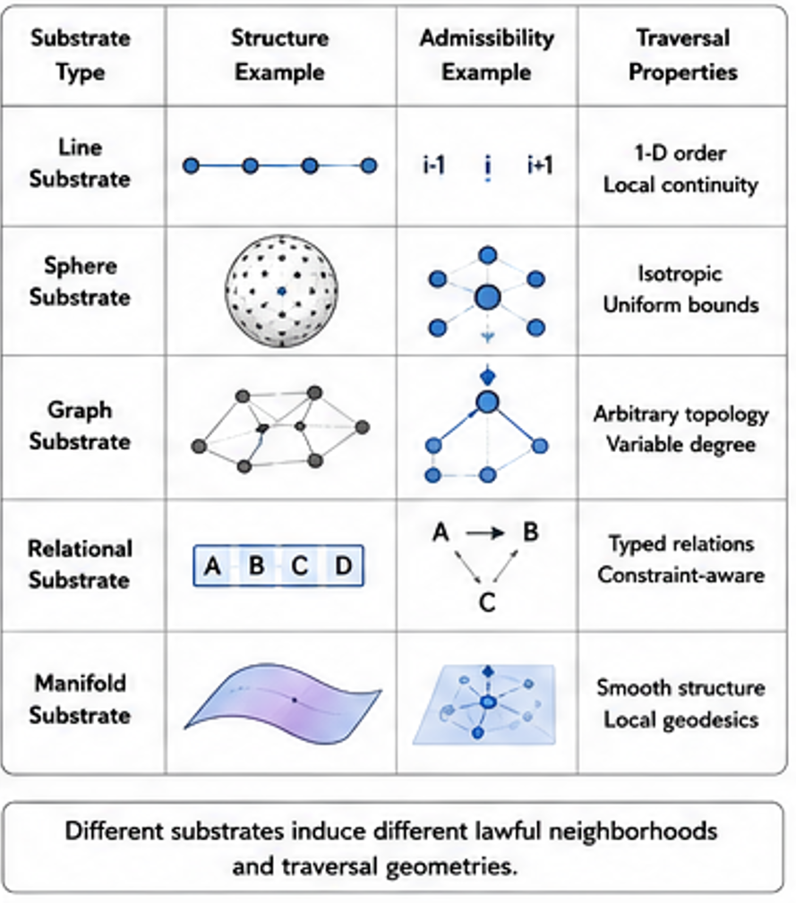
Figure 4 illustrates multiple transformational substrate classes.
In some embodiments:
- line-based substrates preserve sequential traversal,
- sphere-based substrates preserve bounded lawful neighborhoods and rotational equivalence,
- and recursive relational substrates preserve recursively composable lawful traversal systems.
Figure 4 may further illustrate:
- substrate-defined adjacency,
- substrate-induced geometry,
- recursive neighborhood induction,
- recursive admissibility structure,
- or recursive transformational continuity.

Figure 5 — Recursive Transformation Grammar
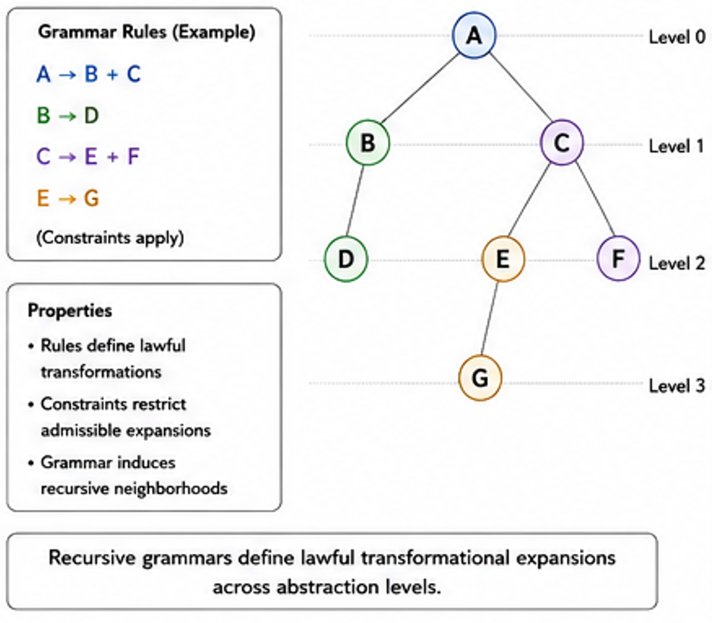
Figure 5 illustrates recursive transformation grammars operating over lawful transformational substrates.
In some embodiments:
- recursively admissible neighborhoods recursively generate higher-order lawful neighborhoods,
- recursively preserved traversal systems induce lawful transformation grammars,
- and recursively organized operational structure recursively constrains future computation.

Figure 6 — Recursive World-Model Traversal System
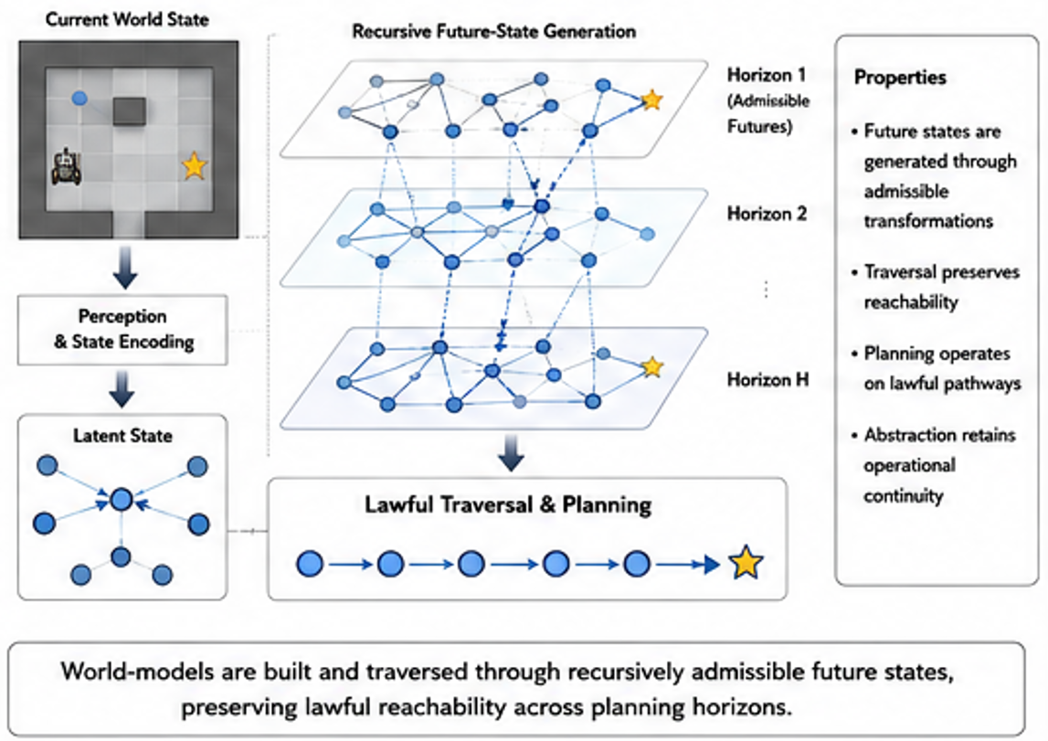
Figure 6 illustrates recursive traversal within recursively organized world-model architectures.
In some embodiments:
- recursively preserved admissibility constrains future-state planning,
- recursively generated operational geometry preserves lawful navigation,
- and recursively organized abstraction systems preserve multi-scale traversal continuity.

Figure 7 — Recursive Admissibility Propagation System
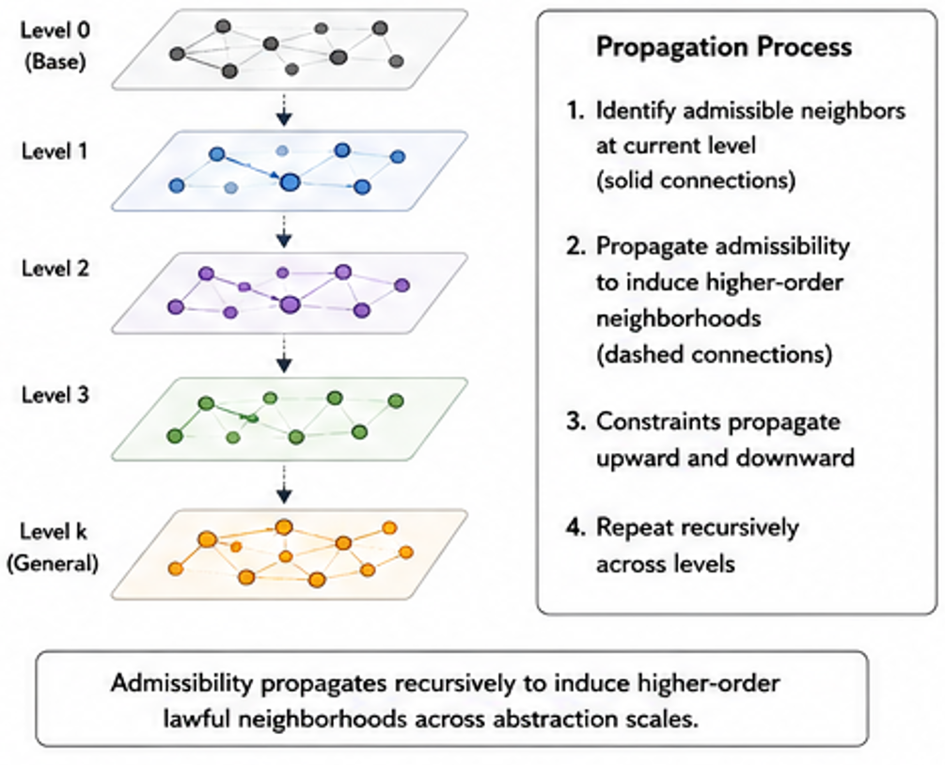
Figure 7 illustrates recursive propagation of lawful admissibility structure across recursively organized abstraction scales.
In some embodiments:
- lawful transformational structure remains operationally active during later recursive computation,
- recursively organized admissibility systems constrain future traversal pathways,
- and recursively preserved operational structure recursively induces stable lawful geometry across scales.

Core Definitions

Transformational Substrate
A transformational substrate comprises a structured relational possibility space within which:
- distinctions,
- neighborhoods,
- transformations,
- adjacency relationships,
- traversal pathways,
- equivalence systems,
- and operational continuity relationships
may emerge.
In some embodiments:
- the substrate defines admissible transformations,
- the substrate constrains lawful traversal,
- and substrate organization determines which recursive structures become computationally natural.
Different substrates naturally privilege different:
- traversal systems,
- transformation grammars,
- equivalence relationships,
- recursive organizations,
- or compressibility properties.
Examples may include:
- line-based substrates,
- graph substrates,
- sphere-based substrates,
- manifold substrates,
- recursive relational substrates,
- symbolic substrates,
- or bounded transformational systems.

Lawful Transformation
A lawful transformation comprises a transformation that preserves operational coherence within a transformational substrate.
In some embodiments:
- lawful transformations preserve admissibility structure,
- lawful transformations preserve valid traversal continuity,
- lawful transformations preserve recursive reachability,
- and lawful transformations preserve operational compatibility across recursive scales.
In some embodiments:
- lawful transformations are defined relative to substrate structure rather than statistical similarity alone.

Admissibility
Admissibility refers to whether a transformation preserves operational coherence within a lawful transformational substrate.
In some embodiments:
- admissibility governs lawful traversal,
- admissibility constrains recursive organization,
- admissibility preserves operational continuity,
- and admissibility determines whether transformations remain computationally valid.
In some embodiments:
- statistical similarity alone does not imply admissibility,
- geometric proximity alone does not imply operational compatibility,
- and recursively preserved admissibility governs lawful computation.

Operational Structure
Operational structure comprises relational structure that remains computationally active during later transformations, recursive abstraction, planning, traversal, inference, or representation formation.
In some embodiments:
- preserved operational structure constrains future traversal,
- recursively preserved operational structure remains active across recursive scales,
- and operational continuity governs lawful recursive computation.
Operational structure may include:
- lawful traversal pathways,
- admissibility systems,
- recursive neighborhood relationships,
- recursive reachability structure,
- lawful equivalence systems,
- or recursively preserved transformation continuity.

Recursive Preservation
Recursive preservation refers to preservation of operationally admissible structure across recursive organizational levels.
In some embodiments:
- recursively preserved neighborhoods constrain future traversal,
- recursively preserved operational structure remains computationally active during later abstraction stages,
- and recursively preserved admissibility propagates lawful transformation structure across recursive scales.

Recursive Admissibility Propagation
Recursive admissibility propagation refers to recursive preservation and propagation of lawful admissibility relationships across recursively organized computational layers.
In some embodiments:
- recursively admissible neighborhoods induce additional admissible neighborhoods,
- recursively preserved traversal systems constrain future computation,
- and recursively organized operational structure recursively generates higher-order lawful transformation systems.

Recursive Neighborhood
A recursive neighborhood comprises a recursively organized set of states connected through admissible transformations.
In some embodiments:
- recursive neighborhoods preserve lawful traversal continuity,
- recursively generated neighborhoods preserve operational reachability,
- and recursive neighborhoods recursively induce higher-order relational organization.
Recursive neighborhoods may preserve:
- adjacency relationships,
- operational compatibility,
- lawful traversal continuity,
- recursive equivalence systems,
- or recursively admissible transformation pathways.

Recursive Reachability
Recursive reachability refers to preservation of lawful accessibility relationships across recursive abstraction scales.
In some embodiments:
- recursively organized abstraction systems preserve lawful navigation,
- recursively generated traversal systems preserve admissible accessibility,
- and recursively induced geometry preserves lawful multi-scale traversal continuity.

Recursive Traversal
Recursive traversal comprises lawful movement through recursively admissible transformational neighborhoods.
In some embodiments:
- traversal is constrained by admissibility relationships,
- recursively preserved operational structure constrains future traversal,
- and recursive traversal preserves lawful continuity across recursive abstraction levels.
Recursive traversal may comprise:
- recursive navigation,
- recursive planning,
- recursive path construction,
- recursive world-model traversal,
- recursive biological traversal,
- or recursively constrained inference systems.

Traversal-Preserving Representation
A traversal-preserving representation comprises a representation that preserves lawful operational traversal relationships.
In some embodiments:
- representations preserve admissible neighborhood structure,
- recursively organized representations preserve lawful reachability,
- and recursively induced geometry preserves operational continuity during abstraction and transfer.
In some embodiments:
- representation quality depends on preservation of lawful traversal continuity rather than statistical similarity alone.

Operational Geometry
Operational geometry comprises geometry induced from lawful transformational continuity rather than externally imposed metric structure.
In some embodiments:
- lawful transformations induce operational geometry,
- recursively admissible traversal systems induce lawful reachability structure,
- and recursively organized neighborhoods generate stable traversal geometry.
Operational geometry may preserve:
- lawful traversal pathways,
- recursive reachability,
- recursive path continuity,
- operational geodesics,
- or recursively admissible transformation structure.

Operational Geodesic
An operational geodesic comprises a lawful traversal pathway preserving admissible operational continuity between states.
In some embodiments:
- operational geodesics preserve lawful traversal structure,
- recursively preserved admissibility constrains geodesic continuity,
- and operational geodesics preserve recursive reachability relationships.

Recursive Transformation Grammar
A recursive transformation grammar comprises a recursively organized lawful transformation system in which recursively admissible neighborhoods recursively generate additional lawful neighborhoods.
In some embodiments:
- recursive transformation grammars preserve lawful traversal continuity,
- recursively generated neighborhoods induce recursively composable traversal systems,
- and recursively organized operational structure recursively constrains future transformations.
Recursive transformation grammars may operate over:
- symbolic systems,
- graph systems,
- geometric systems,
- biological systems,
- latent systems,
- planning systems,
- or recursively organized world-model architectures.

Recursive Generative Primitive
A recursive generative primitive comprises a compact bounded relational system configured to recursively generate higher-order lawful transformational organization.
In some embodiments:
- recursively generated lawful neighborhoods induce additional lawful neighborhoods,
- recursively organized transformations recursively induce additional transformation spaces,
- and recursively generated operational structure recursively propagates lawful organization across scales.
Examples may include:
- recursive sphere systems,
- recursive graph systems,
- recursive neighborhood generators,
- recursive symmetry systems,
- recursively composable bounded geometries,
- or recursively organized transformational primitives.

Recursive Equivalence System
A recursive equivalence system comprises recursively organized admissibility relationships preserving lawful operational continuity between recursively related states or transformations.
In some embodiments:
- recursively equivalent transformations preserve lawful traversal structure,
- recursively organized equivalence systems preserve operational compatibility,
- and recursive equivalence relationships reduce independently reconstructable operational relationships.

Recursive Transfer Compatibility
Recursive transfer compatibility refers to compatibility between systems preserving lawful operational structure across recursive scales.
In some embodiments:
- transfer compatibility depends on preservation of admissibility structure,
- recursively preserved traversal systems improve transfer stability,
- and recursively organized operational geometry governs meaningful cross-system transfer.
In some embodiments:
- statistical similarity alone does not guarantee recursive transfer compatibility.

Transformational Substrate Systems

Transformational Substrate Systems
The present disclosure introduces transformational substrate systems in which:
- lawful transformations define admissible computational structure,
- recursively preserved operational continuity constrains future traversal,
- and recursively organized admissibility relationships induce stable operational geometry across recursive scales.
Unlike conventional computational systems that treat representations as relatively substrate-independent statistical objects, the disclosed architectures recognize that:
- substrate structure fundamentally determines lawful traversal,
- substrate structure governs admissibility relationships,
- substrate structure determines recursive compressibility,
- and substrate organization constrains which computational transformations remain operationally coherent.
In some embodiments:
- scalable computation emerges from recursively preserved admissibility operating over lawful transformational substrates.

Substrate-Defined Computation
In some embodiments:
- computation is defined through lawful traversal of admissible transformations within a substrate.
Unlike unconstrained optimization systems:
- lawful traversal preserves operational continuity,
- recursively admissible neighborhoods preserve lawful reachability,
- and recursively preserved structure constrains future computational transitions.
In some embodiments:
- substrate structure determines:
  - lawful adjacency,
  - admissible traversal,
  - recursive neighborhood formation,
  - operational continuity,
  - recursive equivalence structure,
  - and recursive transformational persistence.
In some embodiments:
- different substrates naturally privilege different computational organizations.
Examples may include:
- directional traversal systems,
- bounded neighborhood systems,
- recursive equivalence systems,
- recursive lawful grammars,
- recursive navigation systems,
- or recursively admissible planning systems.

Line-Based Substrates
In some embodiments:
- line-based substrates preserve directional progression and sequential organization.
Line-based substrates may privilege:
- ordered traversal,
- scalar progression,
- sequential indexing,
- directional adjacency,
- or linear neighborhood systems.
In some embodiments:
- lawful traversal occurs primarily through directional continuity,
- neighborhoods emerge from sequential adjacency,
- and traversal systems preserve ordered operational progression.
Line-based substrates may naturally support:
- sequential symbolic systems,
- temporal systems,
- directional planning systems,
- or recursively ordered traversal architectures.
However:
- line-based substrates may exhibit limited bounded neighborhood structure,
- reduced rotational equivalence,
- or limited recursive adjacency closure.

Sphere-Based Substrates
In some embodiments:
- sphere-based substrates preserve bounded lawful neighborhoods and rotational equivalence relationships.
Sphere-based substrates may privilege:
- bounded traversal continuity,
- recursive adjacency closure,
- rotational equivalence,
- recursive lawful neighborhood induction,
- and recursively admissible multi-directional traversal.
In some embodiments:
- neighborhoods emerge through geodesic organization,
- lawful traversal preserves bounded operational continuity,
- and recursively organized sphere systems preserve lawful reachability across recursive scales.
In some embodiments:
- recursively generated sphere neighborhoods induce higher-order lawful neighborhoods,
- recursive symmetry systems preserve operational equivalence relationships,
- and recursively admissible traversal systems preserve lawful transformation continuity.
Sphere-based substrates may naturally support:
- recursive neighborhood generation,
- recursive lawful compression,
- recursive equivalence systems,
- recursive planning systems,
- recursive navigation systems,
- or recursively admissible traversal architectures.

Recursive Relational Substrates
In some embodiments:
- recursive relational substrates preserve recursively composable operational structure.
Recursive relational substrates may preserve:
- recursive neighborhood generation,
- recursive admissibility propagation,
- recursive traversal continuity,
- recursive equivalence systems,
- recursive lawful transformation grammars,
- or recursively induced operational geometry.
In some embodiments:
- recursively generated lawful neighborhoods recursively induce additional lawful neighborhoods,
- recursively organized traversal systems preserve operational continuity across abstraction scales,
- and recursively preserved admissibility recursively constrains future computational organization.
Recursive relational substrates may naturally support:
- recursive planning,
- recursive abstraction,
- recursive lawful compression,
- recursive world-model traversal,
- recursive biological traversal,
- or recursively constrained inference systems.

Substrate-Induced Operational Geometry
In some embodiments:
- lawful operational geometry emerges from admissible transformational continuity operating over lawful substrates.
Unlike systems that impose geometry externally:
- operational geometry is induced from lawful traversal structure,
- recursively admissible neighborhoods induce lawful reachability structure,
- and recursively preserved operational continuity induces stable multi-scale geometry.
In some embodiments:
- geometry is secondary to lawful traversal,
- lawful traversal induces operational neighborhoods,
- and recursively organized admissibility relationships induce operational geodesics.
Operational geometry may preserve:
- recursive path continuity,
- lawful traversal systems,
- recursive reachability,
- operational equivalence structure,
- recursive neighborhood continuity,
- or recursively admissible transformation systems.

Substrate-Defined Compressibility
In some embodiments:
- transformational substrates determine recursive compressibility properties.
Different substrates naturally support different:
- recursive equivalence systems,
- lawful neighborhood organizations,
- traversal continuity relationships,
- recursive symmetry systems,
- or admissibility-preserving abstraction systems.
In some embodiments:
- bounded lawful substrates reduce independently reconstructable operational relationships,
- recursively admissible traversal systems preserve lawful compression structure,
- and recursively preserved operational continuity supports scalable recursive abstraction.
In some embodiments:
- recursive compressibility emerges from lawful transformational organization rather than dimensional reduction alone.

Recursive Admissibility Systems
In some embodiments:
- recursively admissible transformations recursively induce higher-order admissibility structure.
Recursive admissibility systems may preserve:
- lawful traversal continuity,
- recursive operational persistence,
- recursive reachability,
- recursive lawful neighborhood organization,
- or recursively admissible abstraction structure.
In some embodiments:
- recursively preserved admissibility remains computationally active during later recursive stages,
- recursively organized lawful traversal systems constrain future computation,
- and recursively induced operational structure preserves lawful transformational continuity across abstraction scales.

Recursive Transformational Continuity
In some embodiments:
- lawful transformational continuity preserves operational coherence during recursive traversal, abstraction, planning, inference, transfer, or compression.
In some embodiments:
- recursively preserved operational structure constrains future traversal pathways,
- recursively organized neighborhoods preserve lawful continuity,
- and recursively admissible transformations preserve operational compatibility across recursive scales.
Recursive transformational continuity may preserve:
- recursive path fidelity,
- lawful navigation consistency,
- recursive traversal coherence,
- recursive geometry preservation,
- recursive planning continuity,
- or recursively admissible transfer structure.

Substrate-Aware Representation Formation
In some embodiments:
- representation systems preserve substrate-defined admissibility relationships prior to manifold learning.
Unlike conventional embedding systems:
- representations are not generated independently from lawful traversal structure,
- substrate-defined admissibility constrains representation formation,
- and recursively organized operational structure governs lawful representation continuity.
In some embodiments:
- recursively admissible neighborhoods define lawful representational organization,
- recursively preserved traversal systems constrain latent geometry,
- and recursively induced operational structure preserves meaningful transformation continuity during learning.

Recursive World-Model Substrates
In some embodiments:
- world-model architectures operate over lawful transformational substrates.
In some embodiments:
- recursively admissible traversal systems preserve lawful future-state reachability,
- recursively preserved operational continuity constrains planning trajectories,
- and recursively organized operational geometry preserves lawful navigation across recursive abstraction scales.
Recursive world-model substrates may support:
- recursive planning,
- recursive traversal preservation,
- recursive navigation systems,
- recursive abstraction-preserving prediction,
- or recursively admissible future-state generation.

Recursive Biological Substrates
In some embodiments:
- biological systems operate as lawful transformational substrates.
Biological substrates may preserve:
- admissible mutation structure,
- recursive biological traversal,
- recursive functional continuity,
- recursive neighborhood preservation,
- recursive transfer compatibility,
- or recursively admissible evolutionary pathways.
In some embodiments:
- recursively preserved biological admissibility constrains future biological transformations,
- recursively organized biological neighborhoods preserve lawful functional traversal,
- and recursively induced biological geometry preserves operational continuity across biological abstraction scales.

Recursive Indexing Framework

Recursive Indexing Framework
The present disclosure introduces recursive indexing systems configured to preserve lawful transformational continuity across recursively organized computational scales.
Unlike conventional indexing systems that:
- statically map symbols,
- preserve coordinate locality without operational continuity,
- or organize representations independently from lawful traversal structure,
the disclosed systems:
- recursively preserve admissibility relationships,
- recursively organize lawful neighborhoods,
- recursively constrain future traversal,
- and recursively induce operational geometry from lawful transformational continuity.
In various embodiments:
- recursive indexing operates over lawful transformational substrates,
- recursively admissible neighborhoods recursively induce higher-order lawful neighborhoods,
- recursively preserved operational structure remains computationally active during later recursive stages,
- and recursively organized traversal systems preserve lawful reachability across abstraction scales.

Core Recursive Indexing Principle
In some embodiments:
- recursively preserved admissibility structure constrains future organization.
In contrast to conventional systems where:
- earlier representations are often overwritten,
- abstraction destroys lawful traversal continuity,
- or operational structure is discarded during compression,
the disclosed architectures preserve:
- lawful traversal relationships,
- admissible transformation continuity,
- recursive reachability structure,
- and operationally active neighborhood organization
across recursive abstraction levels.
In some embodiments:
- recursively organized neighborhoods recursively generate additional lawful neighborhoods,
- recursively preserved traversal systems recursively induce higher-order operational geometry,
- and recursively admissible organizational structure recursively constrains future computation.

Recursive Indexing Operator
In some embodiments, recursive indexing proceeds according to:
$$I^{\left(k+1\right)}=R\left(I^{\left(k\right)},A^{\left(k\right)},S\right)$$
where:
- $I^{\left(k\right)}$ represents recursive organizational structure at recursive level kkk,
- $A^{\left(k\right)}$ represents admissibility structure,
- $S$ represents substrate structure,
- and $R$ represents a recursive indexing operator.
In some embodiments:
- recursive indexing preserves lawful transformational continuity,
- recursively admissible neighborhoods preserve operational reachability,
- and recursively induced geometry preserves lawful traversal consistency across recursive scales.

Recursive Admissibility Propagation
In some embodiments:
- admissibility relationships propagate recursively through recursively organized computational layers.
Recursive admissibility propagation may preserve:
- lawful traversal continuity,
- recursive reachability,
- operational neighborhood structure,
- recursive equivalence systems,
- recursive path consistency,
- or recursively admissible transformational continuity.
In some embodiments:
- recursively preserved lawful neighborhoods constrain future traversal systems,
- recursively organized admissibility relationships recursively induce higher-order operational geometry,
- and recursively admissible traversal systems recursively preserve lawful computational continuity.

Recursive Neighborhood Induction
In some embodiments:
- recursive neighborhoods recursively induce additional lawful neighborhoods.
Unlike static neighborhood systems:
- recursively organized neighborhoods preserve operational continuity,
- recursively admissible neighborhoods remain computationally active during later recursive stages,
- and recursively generated neighborhoods recursively constrain future organizational structure.
Recursive neighborhood induction may preserve:
- lawful adjacency relationships,
- recursive operational continuity,
- recursive traversal coherence,
- recursive equivalence systems,
- or recursively admissible path structure.
In some embodiments:
- recursively induced neighborhoods preserve lawful transformational continuity across abstraction scales.

Recursive Operational Geometry
In some embodiments:
- recursive indexing induces operational geometry from lawful transformational continuity.
Unlike externally imposed geometric systems:
- geometry emerges from admissible traversal structure,
- recursively admissible neighborhoods induce lawful reachability systems,
- and recursively organized operational continuity induces stable traversal geometry.
Operational geometry may preserve:
- lawful traversal pathways,
- recursive geodesics,
- recursive reachability continuity,
- operational neighborhood structure,
- recursive path fidelity,
- or recursively admissible abstraction continuity.
In some embodiments:
- recursively organized operational geometry constrains future computation.

Recursive Transformation Grammars
In some embodiments:
- recursive indexing systems operate as recursive transformation grammars.
Recursive transformation grammars may:
- recursively generate lawful transformational structure,
- recursively organize admissible traversal systems,
- recursively preserve operational continuity,
- and recursively induce higher-order lawful organizational structure.
In some embodiments:
- recursively admissible neighborhoods recursively generate additional lawful neighborhoods,
- recursively organized transformational continuity recursively induces lawful traversal grammars,
- and recursively preserved admissibility recursively constrains future transformations.
Recursive transformation grammars may operate over:
- symbolic systems,
- graph systems,
- biological systems,
- world-model systems,
- recursive planning systems,
- geometric systems,
- latent systems,
- or recursively organized operational substrates.

Recursive Traversal Preservation
In some embodiments:
- recursive indexing preserves lawful traversal continuity during recursive abstraction.
Recursive traversal preservation may preserve:
- recursive path fidelity,
- lawful navigation continuity,
- recursive reachability,
- operational geodesics,
- recursive planning continuity,
- or recursively admissible traversal structure.
In some embodiments:
- recursively meaningful abstraction preserves traversal continuity more effectively than arbitrary abstraction,
- recursively admissible traversal systems preserve lawful navigation structure,
- and recursively organized traversal continuity preserves operational coherence across recursive scales.
Operational traversal-preservation metrics may include:
- path-fidelity retention,
- recursive reachability consistency,
- geodesic distortion,
- bottleneck preservation,
- recursive hierarchy consistency,
- recursive traversal coherence,
- or recursively admissible path-preservation metrics.

Recursive Equivalence Induction
In some embodiments:
- recursive indexing induces recursive equivalence systems preserving lawful operational continuity.
Recursive equivalence systems may preserve:
- lawful transformational compatibility,
- recursive traversal continuity,
- admissible neighborhood structure,
- recursive reachability consistency,
- or recursively admissible organizational structure.
In some embodiments:
- recursively equivalent transformations reduce independently reconstructable operational relationships,
- recursively organized equivalence systems preserve lawful traversal continuity,
- and recursively admissible equivalence structure improves recursive transfer stability.

Recursive Abstraction Systems
In some embodiments:
- recursive abstraction preserves lawful operational continuity across recursive scales.
Recursive abstraction systems may preserve:
- recursive traversal structure,
- lawful reachability continuity,
- recursive neighborhood organization,
- recursive admissibility propagation,
- or recursively admissible planning structure.
Unlike conventional abstraction systems:
- recursively preserved operational structure remains computationally active after abstraction,
- recursively organized traversal systems preserve lawful continuity,
- and recursively induced operational geometry preserves admissible transformational structure during compression and coarsening.

Recursive World-Model Indexing
In some embodiments:
- recursive indexing organizes lawful future-state traversal within world-model architectures.
In some embodiments:
- recursively admissible traversal systems constrain future-state planning,
- recursively preserved operational continuity preserves lawful navigation pathways,
- and recursively induced geometry preserves multi-scale traversal consistency during planning and prediction.
Recursive world-model indexing may support:
- recursive planning,
- recursive future-state traversal,
- recursive navigation,
- recursive abstraction-preserving prediction,
- or recursively admissible trajectory generation.

Recursive Biological Indexing
In some embodiments:
- recursive indexing organizes lawful biological transformational structure.
Recursive biological indexing may preserve:
- admissible mutation structure,
- recursive biological traversal,
- recursive functional continuity,
- recursive neighborhood preservation,
- recursive transfer compatibility,
- or recursively admissible biological pathways.
In some embodiments:
- recursively preserved biological admissibility constrains future biological transformations,
- recursively organized biological neighborhoods preserve lawful functional traversal,
- and recursively induced biological geometry preserves operational continuity across biological abstraction scales.

Recursive Representation Formation Systems

Recursive Representation Formation Systems
The present disclosure introduces recursive representation formation systems in which:
- lawful transformational continuity governs representation organization,
- recursively admissible traversal structure constrains representational geometry,
- and recursively preserved operational structure remains computationally active across recursive abstraction scales.
Unlike conventional representation-learning systems that:
- generate embeddings prior to lawful organizational structure,
- optimize latent similarity independently from admissibility,
- or reconstruct operational structure statistically after representation formation,
the disclosed systems:
- organize lawful transformational continuity before or during representation generation,
- recursively preserve admissible traversal systems,
- and induce stable operational geometry from recursively preserved admissibility relationships.
In some embodiments:
- recursively organized lawful neighborhoods define representational structure prior to manifold optimization,
- recursively admissible traversal systems constrain latent organization,
- and recursively preserved operational continuity governs lawful abstraction and transfer.

Representation As Derived Structure
In some embodiments:
- representations are derived from lawful traversal structure rather than serving as primary computational primitives.
Unlike systems in which:
- latent proximity determines operational compatibility,
- similarity metrics define computational structure,
- or embeddings operate independently from lawful traversal continuity,
the disclosed systems:
- derive representational organization from admissibility-preserving traversal systems,
- preserve lawful operational continuity during abstraction,
- and recursively constrain representational structure through recursively preserved admissibility relationships.
In some embodiments:
- operational structure precedes embedding organization,
- recursively admissible traversal induces lawful representational geometry,
- and recursively organized neighborhoods preserve operational continuity during learning.

Pre-Embedding Structural Organization
In some embodiments:
- recursive indexing organizes lawful structure prior to embedding generation.
Pre-embedding structural organization may preserve:
- admissible neighborhood systems,
- lawful traversal continuity,
- recursive reachability,
- recursive equivalence structure,
- operational geodesics,
- or recursively admissible transformational continuity.
In some embodiments:
- recursively organized admissibility relationships constrain representation formation before statistical optimization begins,
- recursively preserved operational continuity constrains latent organization,
- and recursively induced geometry preserves lawful traversal systems during learning.
Unlike conventional embedding systems:
- representational structure is not generated independently from operational admissibility.

Traversal-Preserving Representations
In some embodiments:
- representations preserve lawful traversal continuity across abstraction scales.
Traversal-preserving representations may preserve:
- recursive path fidelity,
- lawful reachability continuity,
- recursive navigation structure,
- recursive traversal coherence,
- operational geodesics,
- or recursively admissible neighborhood continuity.
In some embodiments:
- recursively organized representations preserve lawful traversal more effectively than representations optimized solely for latent similarity,
- recursively preserved operational structure remains computationally active during later inference stages,
- and recursively admissible traversal systems preserve lawful continuity during abstraction and compression.

Operational Geometry Preservation
In some embodiments:
- recursive representation systems preserve operational geometry induced from lawful transformational continuity.
Operational geometry preservation may preserve:
- lawful traversal pathways,
- recursive geodesics,
- recursive neighborhood continuity,
- recursive reachability,
- operational equivalence systems,
- or recursively admissible path structure.
In some embodiments:
- recursively preserved operational geometry constrains future representational organization,
- recursively admissible traversal systems induce stable multi-scale geometry,
- and recursively organized operational continuity preserves lawful abstraction structure.
Unlike externally imposed metric systems:
- operational geometry emerges from admissible traversal continuity.

Recursive Representational Continuity
In some embodiments:
- recursively preserved operational structure remains active during later representational abstraction stages.
Recursive representational continuity may preserve:
- lawful operational relationships,
- recursive traversal systems,
- recursive admissibility structure,
- recursive neighborhood continuity,
- recursive equivalence systems,
- or recursively admissible transformational persistence.
In some embodiments:
- recursively preserved structure constrains future representation formation,
- recursively organized admissibility systems preserve lawful continuity during recursive abstraction,
- and recursively induced operational geometry preserves meaningful transformation structure across scales.

Representation Stability Through Admissibility
In some embodiments:
- representation stability emerges from recursively preserved admissibility structure rather than statistical stabilization alone.
Unlike systems that:
- stabilize latent representations through predictive consistency objectives,
- enforce representation similarity statistically,
- or preserve embeddings independently from lawful traversal continuity,
the disclosed architectures:
- preserve lawful operational structure recursively,
- preserve admissible transformational continuity,
- and preserve lawful traversal systems across recursive abstraction scales.
In some embodiments:
- stable representations emerge from recursively conserved admissibility structure operating over lawful transformational substrates.

Recursive Latent Organization
In some embodiments:
- recursively admissible traversal systems constrain latent-space organization.
Recursive latent organization may preserve:
- lawful neighborhood continuity,
- recursive traversal structure,
- recursive operational reachability,
- operational geodesics,
- recursive path continuity,
- or recursively admissible equivalence systems.
In some embodiments:
- recursively organized operational structure reduces latent instability,
- recursively admissible traversal systems preserve lawful representational continuity,
- and recursively induced geometry constrains latent abstraction pathways.

Recursive Representation Transfer
In some embodiments:
- transfer compatibility depends on preservation of lawful operational continuity rather than similarity alone.
Recursive representation transfer may preserve:
- recursive traversal structure,
- lawful neighborhood continuity,
- recursive admissibility systems,
- recursive operational geometry,
- recursive reachability,
- or recursively admissible transformational structure.
In some embodiments:
- recursively preserved traversal systems improve transfer stability,
- recursively admissible neighborhood alignment improves generalization,
- and recursively organized operational geometry governs meaningful transfer compatibility.
In some embodiments:
- statistically similar systems may remain operationally incompatible if lawful traversal continuity is not preserved.

Recursive Representation Compression
In some embodiments:
- recursive representation systems support lawful abstraction and compression while preserving operational continuity.
Recursive representational compression may preserve:
- lawful traversal pathways,
- recursive reachability,
- recursive neighborhood continuity,
- operational geodesics,
- recursive path fidelity,
- or recursively admissible abstraction structure.
In some embodiments:
- recursively meaningful abstraction preserves lawful traversal continuity more effectively than arbitrary dimensionality reduction,
- recursively organized operational structure remains computationally active during compression,
- and recursively admissible geometry preserves lawful representational continuity across abstraction scales.

Recursive Multi-Scale Representation Systems
In some embodiments:
- recursively organized representation systems preserve lawful continuity across multiple abstraction scales.
Recursive multi-scale representation systems may preserve:
- local lawful traversal,
- global reachability continuity,
- recursive operational persistence,
- recursive admissibility structure,
- recursive planning continuity,
- or recursively admissible transformational organization.
In some embodiments:
- recursively admissible neighborhoods recursively induce higher-order lawful representational systems,
- recursively preserved operational continuity remains active across abstraction levels,
- and recursively organized operational geometry preserves lawful computational continuity during scaling.

Operational Representation Metrics
In some embodiments:
- recursive representation systems are evaluated using operational continuity metrics rather than latent similarity alone.
Operational representation metrics may include:
- recursive path-fidelity retention,
- recursive reachability preservation,
- operational geodesic continuity,
- bottleneck consistency,
- recursive hierarchy preservation,
- recursive traversal coherence,
- recursive neighborhood continuity,
- geodesic distortion,
- recursive transfer compatibility,
- or recursively admissible traversal-preservation metrics.
In some embodiments:
- representation quality depends on preservation of lawful operational continuity across recursive scales.

Recursive AI, Planning, and World-Model Systems

Recursive AI Systems
The present disclosure introduces recursive artificial intelligence systems in which:
- lawful transformational continuity governs computational organization,
- recursively admissible traversal constrains inference and planning,
- and recursively preserved operational structure remains computationally active across recursive abstraction scales.
Unlike conventional artificial intelligence systems that:
- reconstruct structure statistically after representation formation,
- optimize latent organization independently from lawful traversal continuity,
- or treat embeddings as primary computational primitives,
the disclosed systems:
- preserve lawful transformational continuity before or during learning,
- recursively organize admissible neighborhoods,
- preserve lawful traversal continuity during abstraction,
- and recursively constrain computation through recursively preserved admissibility structure.
In some embodiments:
- recursively organized transformational substrates define lawful computational structure prior to optimization,
- recursively admissible traversal systems constrain representational organization,
- and recursively induced operational geometry preserves lawful inference continuity.

Substrate-Aware AI Systems
In some embodiments:
- artificial intelligence systems operate over lawful transformational substrates.
Unlike substrate-independent statistical architectures:
- substrate-aware systems preserve lawful transformational continuity,
- recursively organized admissibility systems constrain computation,
- and substrate-defined traversal structure governs representational organization and planning.
In some embodiments:
- substrate structure determines lawful adjacency,
- substrate structure constrains admissible traversal,
- recursively preserved operational continuity remains computationally active during inference,
- and recursively organized operational geometry constrains future computational organization.
Examples may include:
- sphere-based substrates,
- graph substrates,
- recursive relational substrates,
- manifold substrates,
- symbolic substrates,
- or recursively admissible operational substrates.

Recursive World-Model Architectures
In some embodiments:
- recursively organized lawful transformational substrates support world-model computation.
Recursive world-model architectures may preserve:
- lawful future-state reachability,
- recursive traversal continuity,
- recursive planning structure,
- recursive abstraction continuity,
- operational geodesics,
- or recursively admissible future-state generation.
In some embodiments:
- recursively admissible traversal systems constrain future-state prediction,
- recursively preserved operational continuity constrains planning trajectories,
- and recursively induced operational geometry preserves lawful navigation across recursive abstraction scales.
Unlike unconstrained predictive systems:
- recursively organized world models preserve lawful traversal continuity during prediction and planning.

Recursive Planning Systems
In some embodiments:
- planning proceeds through recursively admissible traversal rather than unconstrained optimization.
Recursive planning systems may preserve:
- lawful navigation continuity,
- recursive reachability,
- recursive path fidelity,
- recursive traversal coherence,
- recursive operational continuity,
- or recursively admissible trajectory generation.
In some embodiments:
- recursively preserved admissibility constrains future planning pathways,
- recursively organized traversal systems preserve lawful navigation continuity,
- and recursively induced operational geometry preserves meaningful multi-scale planning structure.
Recursive planning may support:
- robotic navigation,
- world-model planning,
- recursive decision systems,
- recursive inference systems,
- autonomous navigation,
- or recursively constrained traversal architectures.

Recursive Traversal Systems
In some embodiments:
- recursive traversal systems preserve lawful operational continuity during computation.
Recursive traversal systems may preserve:
- recursive path continuity,
- lawful reachability,
- recursive geodesics,
- recursive operational persistence,
- recursive navigation continuity,
- or recursively admissible transformational coherence.
In some embodiments:
- recursively admissible traversal systems reduce invalid computational transitions,
- recursively preserved operational structure constrains future traversal,
- and recursively organized lawful neighborhoods preserve computational continuity during abstraction and scaling.
Unlike unconstrained latent traversal systems:
- recursive traversal preserves lawful operational continuity across recursive scales.

Recursive Inference Systems
In some embodiments:
- inference proceeds through recursively admissible transformational continuity.
Recursive inference systems may preserve:
- lawful traversal continuity,
- recursive operational reachability,
- recursive neighborhood consistency,
- recursive equivalence structure,
- operational geodesics,
- or recursively admissible abstraction continuity.
In some embodiments:
- recursively preserved admissibility constrains inferential trajectories,
- recursively organized operational structure preserves lawful computational continuity,
- and recursively induced geometry constrains future inference pathways.
Unlike unconstrained statistical inference systems:
- recursive inference systems preserve lawful operational structure during abstraction and prediction.

Recursive Multi-Scale Computation
In some embodiments:
- recursively organized lawful substrates support coherent multi-scale computation.
Recursive multi-scale computation may preserve:
- local lawful traversal,
- global reachability continuity,
- recursive operational persistence,
- recursive abstraction continuity,
- recursive planning structure,
- or recursively admissible transformational organization.
In some embodiments:
- recursively admissible neighborhoods recursively induce higher-order lawful neighborhoods,
- recursively preserved operational continuity remains active during later recursive stages,
- and recursively organized operational geometry preserves lawful continuity across abstraction scales.

Recursive Computational Continuity
In some embodiments:
- recursively preserved operational structure remains computationally active during later inference, planning, abstraction, and traversal stages.
Recursive computational continuity may preserve:
- lawful traversal systems,
- recursive operational geometry,
- recursive admissibility relationships,
- recursive neighborhood continuity,
- recursive equivalence structure,
- or recursively admissible transformational persistence.
In some embodiments:
- recursively preserved lawful structure constrains future computational organization,
- recursively admissible traversal systems preserve operational continuity during recursive abstraction,
- and recursively induced geometry preserves lawful computational coherence during scaling.

Recursive Transfer Systems
In some embodiments:
- transfer compatibility depends on preservation of lawful operational continuity across recursively organized systems.
Recursive transfer systems may preserve:
- recursive traversal structure,
- lawful neighborhood continuity,
- recursive admissibility relationships,
- recursive operational geometry,
- recursive reachability,
- or recursively admissible transformational continuity.
In some embodiments:
- recursively preserved traversal systems improve transfer stability,
- recursively organized operational geometry governs meaningful transfer compatibility,
- and recursively admissible neighborhood alignment improves cross-system generalization.
In some embodiments:
- statistically similar systems may remain operationally incompatible if lawful traversal continuity is not preserved.

Recursive Operational Stability
In some embodiments:
- computational stability emerges from recursively preserved admissibility structure rather than statistical stabilization alone.
Recursive operational stability may preserve:
- lawful traversal continuity,
- recursive operational geometry,
- recursive neighborhood coherence,
- recursive abstraction continuity,
- recursive path fidelity,
- or recursively admissible transformational persistence.
In some embodiments:
- recursively preserved operational continuity constrains future computational organization,
- recursively admissible traversal systems preserve lawful inference continuity,
- and recursively induced geometry preserves meaningful operational stability during scaling and transfer.

Operational AI Metrics
In some embodiments:
- recursive AI systems are evaluated using operational continuity metrics rather than statistical similarity metrics alone.
Operational metrics may include:
- recursive path-fidelity retention,
- recursive reachability preservation,
- operational geodesic continuity,
- recursive traversal coherence,
- recursive planning consistency,
- recursive hierarchy preservation,
- recursive transfer compatibility,
- recursive abstraction continuity,
- bottleneck preservation,
- geodesic distortion,
- or recursively admissible traversal-preservation metrics.
In some embodiments:
- AI system quality depends on preservation of lawful operational continuity across recursive computational scales.

Recursive Biological Systems and Operational Embodiments

Recursive Biological Systems
The present disclosure introduces recursive biological systems in which:
- biological transformations preserve lawful operational continuity,
- recursively admissible biological traversal constrains future biological organization,
- and recursively preserved biological structure remains operationally active across recursive abstraction scales.
Unlike conventional biological representation systems that:
- model biological structure primarily through statistical similarity,
- optimize embeddings independently from lawful biological traversal,
- or treat mutations as relatively independent transformations,
the disclosed systems:
- preserve admissible biological transformation continuity,
- recursively organize lawful biological neighborhoods,
- preserve recursive biological traversal structure,
- and recursively constrain biological inference through recursively preserved admissibility systems.
In some embodiments:
- recursively organized biological substrates preserve lawful biological traversal before predictive modeling occurs,
- recursively admissible biological neighborhoods preserve functional continuity,
- and recursively induced biological geometry preserves lawful transformational organization across biological abstraction scales.

Biological Substrates
In some embodiments:
- biological systems operate as lawful transformational substrates.
Biological substrates may preserve:
- lawful mutation pathways,
- recursive biological reachability,
- recursive functional continuity,
- recursive neighborhood preservation,
- recursive transfer compatibility,
- or recursively admissible evolutionary organization.
Examples may include:
- codon systems,
- nucleotide systems,
- amino-acid systems,
- protein systems,
- functional landscape systems,
- evolutionary systems,
- or recursively organized biological state spaces.
In some embodiments:
- substrate-defined biological admissibility constrains future biological transformations,
- recursively preserved biological continuity constrains functional traversal,
- and recursively organized biological geometry preserves lawful biological operational structure.

Recursive Biological Traversal
In some embodiments:
- biological transformations proceed through recursively admissible traversal systems.
Recursive biological traversal may preserve:
- lawful mutation continuity,
- recursive functional reachability,
- recursive biological neighborhoods,
- recursive operational compatibility,
- recursive evolutionary continuity,
- or recursively admissible functional pathways.
In some embodiments:
- recursively admissible biological traversal preserves functional continuity across recursive scales,
- recursively preserved biological structure constrains future biological organization,
- and recursively organized biological geometry preserves lawful traversal continuity during abstraction and transfer.
Unlike unconstrained similarity-based biological systems:
- recursive biological traversal preserves lawful operational continuity during transformation.

Recursive Functional Neighborhoods
In some embodiments:
- recursive biological systems preserve lawful functional neighborhood structure.
Recursive functional neighborhoods may preserve:
- functional continuity,
- recursive operational compatibility,
- recursive mutation reachability,
- recursive sensitivity organization,
- recursive traversal continuity,
- or recursively admissible biological equivalence systems.
In some embodiments:
- recursively organized biological neighborhoods preserve lawful functional traversal,
- recursively preserved admissibility constrains biological transfer pathways,
- and recursively induced biological geometry preserves meaningful biological continuity across recursive abstraction scales.

Recursive Biological Transfer
In some embodiments:
- biological transfer compatibility depends on preservation of lawful operational continuity rather than statistical similarity alone.
Recursive biological transfer systems may preserve:
- recursive biological traversal,
- lawful functional neighborhood continuity,
- recursive sensitivity structure,
- recursive operational geometry,
- recursive biological reachability,
- or recursively admissible transformational continuity.
In some embodiments:
- recursively preserved biological traversal improves transfer stability,
- recursively admissible neighborhood alignment governs meaningful biological compatibility,
- and recursively organized biological geometry preserves lawful transfer continuity across biological systems.
In some embodiments:
- statistically similar biological systems may remain operationally incompatible if lawful biological traversal continuity is not preserved.

Recursive Biological Geometry
In some embodiments:
- lawful biological geometry emerges from recursively admissible transformational continuity.
Recursive biological geometry may preserve:
- lawful mutation pathways,
- recursive functional continuity,
- recursive biological reachability,
- operational geodesics,
- recursive neighborhood continuity,
- or recursively admissible biological traversal systems.
In some embodiments:
- recursively preserved biological continuity induces stable biological geometry,
- recursively admissible biological neighborhoods induce lawful functional organization,
- and recursively organized biological traversal systems preserve meaningful biological operational structure.

Recursive Biological Abstraction
In some embodiments:
- recursive biological abstraction preserves lawful operational continuity across biological abstraction scales.
Recursive biological abstraction may preserve:
- recursive functional continuity,
- recursive biological traversal,
- recursive mutation reachability,
- recursive neighborhood organization,
- recursive sensitivity structure,
- or recursively admissible biological pathways.
In some embodiments:
- recursively meaningful biological abstraction preserves functional continuity more effectively than arbitrary biological dimensionality reduction,
- recursively preserved operational structure remains biologically active during abstraction,
- and recursively induced biological geometry preserves lawful biological continuity during compression and transfer.

Recursive Biological Operational Continuity
In some embodiments:
- recursively preserved biological structure remains operationally active during later biological transformations.
Recursive biological operational continuity may preserve:
- lawful biological traversal,
- recursive functional persistence,
- recursive mutation continuity,
- recursive neighborhood structure,
- recursive biological equivalence systems,
- or recursively admissible biological transformational continuity.
In some embodiments:
- recursively preserved biological continuity constrains future biological organization,
- recursively admissible biological traversal preserves lawful functional continuity,
- and recursively organized biological geometry preserves meaningful biological operational structure across recursive scales.

Operational Embodiments

Embodiment 1 — Recursive Traversal-Preserving Representation System
In some embodiments:
- recursively admissible traversal systems organize representations prior to manifold optimization,
- recursively preserved operational continuity constrains latent organization,
- and recursively induced geometry preserves lawful traversal continuity during abstraction.
In some embodiments:
- recursive traversal preservation improves representational continuity during scaling and transfer.

Embodiment 2 — Recursive World-Model Planning System
In some embodiments:
- recursively admissible traversal constrains future-state planning,
- recursively preserved operational continuity preserves lawful navigation pathways,
- and recursively organized operational geometry preserves multi-scale planning continuity.
In some embodiments:
- recursive world-model traversal preserves lawful future-state reachability during recursive abstraction.

Embodiment 3 — Recursive Biological Transfer System
In some embodiments:
- recursively preserved biological traversal systems govern biological transfer compatibility,
- recursively admissible neighborhood alignment preserves lawful functional continuity,
- and recursively induced biological geometry constrains biologically meaningful transfer pathways.
In some embodiments:
- transfer compatibility depends on recursively preserved operational structure rather than similarity alone.

Embodiment 4 — Recursive Operational Geometry System
In some embodiments:
- lawful operational geometry emerges from recursively admissible traversal continuity,
- recursively organized neighborhoods preserve lawful reachability,
- and recursively preserved operational structure induces stable operational geometry across recursive scales.
In some embodiments:
- operational geometry governs lawful traversal continuity during inference, planning, abstraction, and transfer.

Embodiment 5 — Recursive Admissibility Propagation System
In some embodiments:
- recursively admissible neighborhoods recursively induce higher-order lawful neighborhoods,
- recursively preserved operational continuity constrains future transformations,
- and recursively organized admissibility systems recursively preserve lawful computational continuity.
In some embodiments:
- recursively preserved admissibility remains operationally active during later recursive abstraction stages.

Embodiment 6 — Recursive Traversal Preservation System
In some embodiments:
- recursively organized abstraction systems preserve lawful traversal continuity across recursive scales,
- recursively preserved operational structure maintains recursive reachability,
- and recursively induced geometry preserves operational geodesic continuity during abstraction and compression.
In some embodiments:
- recursively meaningful abstraction preserves lawful traversal more effectively than arbitrary abstraction systems.

Operational Metrics
In some embodiments:
- recursive systems are evaluated using operational continuity metrics rather than similarity metrics alone.
Operational metrics may include:
- recursive path-fidelity retention,
- recursive reachability preservation,
- recursive neighborhood continuity,
- recursive hierarchy preservation,
- recursive traversal coherence,
- recursive operational geodesic continuity,
- recursive transfer compatibility,
- recursive abstraction continuity,
- bottleneck preservation,
- geodesic distortion,
- recursive functional continuity,
- recursive biological compatibility,
- or recursively admissible traversal-preservation metrics.
In some embodiments:
- computational quality depends on preservation of lawful operational continuity across recursive scales.

Example Algorithms and Computational Frameworks

Example Algorithms
The following algorithms illustrate example embodiments of lawful transformational substrate architectures.
The disclosed algorithms are illustrative only and do not limit the scope of the present disclosure.
In various embodiments:
- lawful traversal,
- recursive admissibility propagation,
- recursive neighborhood induction,
- recursive operational continuity,
- recursive transfer compatibility,
- and recursive abstraction preservation
may be implemented using alternative recursive organizational systems.

Algorithm 1 — Recursive Admissibility Propagation
In some embodiments:
- recursively admissible neighborhoods recursively induce higher-order lawful neighborhoods.
states = initialize_states()
substrate = initialize_substrate()
admissibility = initialize_admissibility()
recursive_structure = []
for level in range(max_levels):
lawful_neighbors = generate_admissible_neighbors(
states,
admissibility,
substrate
)
recursive_structure.append(
lawful_neighbors
)
states = lawful_neighbors
In some embodiments:
- recursively preserved admissibility constrains future neighborhood formation,
- recursively organized neighborhoods preserve lawful traversal continuity,
- and recursively induced operational structure recursively propagates lawful organization across scales.

Algorithm 2 — Lawful Traversal System
In some embodiments:
- computation proceeds through admissible traversal pathways.
current_state = initialize_state()
while not goal_reached(current_state):
admissible_moves = lawful_neighbors(
current_state
)
next_state = select_admissible_move(
admissible_moves
)
current_state = next_state
In some embodiments:
- lawful traversal preserves operational continuity,
- recursively admissible traversal constrains future computation,
- and recursively organized traversal systems preserve lawful reachability across recursive scales.

Algorithm 3 — Recursive Operational Geometry Formation
In some embodiments:
- operational geometry emerges from lawful transformational continuity.
states = initialize_states()
for state in states:
neighbors = admissible_neighbors(state)
geometry[state] = organize_by_traversal(
neighbors
)
In some embodiments:
- operational geometry is induced from lawful traversal continuity rather than externally imposed metric structure,
- recursively admissible neighborhoods induce lawful reachability systems,
- and recursively organized operational continuity induces stable traversal geometry.

Algorithm 4 — Recursive Traversal Preservation
In some embodiments:
- recursive abstraction preserves lawful traversal continuity.
graph = initialize_graph()
while abstraction_needed(graph):
lawful_regions = identify_admissible_regions(
graph
)
graph = recursively_abstract(
graph,
lawful_regions
)
preserve_traversal_paths(graph)
In some embodiments:
- recursively meaningful abstraction preserves traversal continuity more effectively than arbitrary abstraction,
- recursively admissible traversal systems preserve lawful reachability,
- and recursively organized abstraction systems preserve operational continuity across scales.

Algorithm 5 — Recursive Transfer Compatibility
In some embodiments:
- transfer compatibility depends on preservation of lawful operational continuity.
source_structure = extract_operational_structure(
source_system
)
target_structure = extract_operational_structure(
target_system
)
compatibility = compare_admissibility(
source_structure,
target_structure
)
if compatibility > threshold:
transfer_allowed = True
In some embodiments:
- recursively preserved traversal systems improve transfer stability,
- recursively admissible neighborhood alignment governs meaningful compatibility,
- and recursively organized operational geometry constrains lawful transfer pathways.

Algorithm 6 — Recursive World-Model Traversal
In some embodiments:
- recursive world-model systems preserve lawful future-state reachability.
world_state = initialize_world_state()
while planning_required(world_state):
lawful_future_states = generate_admissible_states(
world_state
)
selected_state = choose_lawful_path(
lawful_future_states
)
world_state = selected_state
In some embodiments:
- recursively admissible traversal constrains future-state planning,
- recursively preserved operational continuity preserves lawful navigation pathways,
- and recursively organized operational geometry preserves meaningful planning continuity.

Algorithm 7 — Recursive Biological Traversal
In some embodiments:
- biological transformations preserve lawful operational continuity.
biological_state = initialize_sequence()
while transformation_required(biological_state):
admissible_mutations = lawful_mutations(
biological_state
)
next_state = select_functional_transition(
admissible_mutations
)
biological_state = next_state
In some embodiments:
- recursively admissible biological traversal preserves functional continuity,
- recursively preserved biological structure constrains future transformations,
- and recursively organized biological geometry preserves lawful biological operational continuity.

Computational Frameworks

Recursive Admissibility Framework
In some embodiments:
- recursive organization proceeds according to:
$A^{\left(k+1\right)}=P\left(A^{\left(k\right)},T^{\left(k\right)},S\right)$
where:
- $A^{\left(k\right)}$ represents admissibility structure,
- $T^{\left(k\right)}$ represents traversal structure,
- $S$ represents substrate structure,
- and $P$ represents a recursive propagation operator.
In some embodiments:
- recursively preserved admissibility constrains future traversal,
- recursively organized neighborhoods preserve lawful continuity,
- and recursively induced operational geometry preserves stable computational organization.

Recursive Operational Geometry Framework
In some embodiments:
- lawful geometry emerges from admissible transformational continuity.
$$G^{\left(k+1\right)}=G\left(A^{\left(k\right)},R^{\left(k\right)},S\right)$$
where:
- $G^{\left(k\right)}$ represents operational geometry,
- $A^{\left(k\right)}$ represents admissibility structure,
- $R^{\left(k\right)}$ represents reachability structure,
- and $S$ represents substrate organization.
In some embodiments:
- recursively admissible traversal systems induce lawful geometry,
- recursively preserved operational continuity preserves operational geodesics,
- and recursively organized neighborhoods preserve lawful reachability across scales.

Recursive Traversal Continuity Framework
In some embodiments:
- recursive traversal continuity proceeds according to:
$T^{\left(k+1\right)}=T\left(T^{\left(k\right)},A^{\left(k\right)},C^{\left(k\right)}\right)$
where:
- $T^{\left(k\right)}$ represents traversal structure,
- $A^{\left(k\right)}$ represents admissibility structure,
- $C^{\left(k\right)}$ represents abstraction or compression structure,
- and $T$ represents a traversal-preservation operator.
In some embodiments:
- recursively organized abstraction systems preserve lawful traversal continuity,
- recursively admissible traversal systems preserve recursive reachability,
- and recursively induced geometry preserves operational continuity during scaling.

Recursive Representation Framework
In some embodiments:
- representations emerge from lawful traversal continuity rather than similarity optimization alone.
$R^{\left(k+1\right)}=F\left(A^{\left(k\right)},T^{\left(k\right)},G^{\left(k\right)}\right)$
where:
- $R^{\left(k\right)}$ represents representational organization,
- $A^{\left(k\right)}$ represents admissibility structure,
- $T^{\left(k\right)}$ represents traversal continuity,
- and $G^{\left(k\right)}$ represents operational geometry.
In some embodiments:
- recursively admissible traversal constrains representational organization,
- recursively preserved operational continuity governs lawful abstraction,
- and recursively induced geometry preserves meaningful representational continuity across recursive scales.

Recursive Transfer Framework
In some embodiments:
- transfer compatibility depends on preservation of lawful operational continuity.
$X = C\left(A_{s}, A_{t}, T_{s}, T_{t}\right)$
where:
- $A_{s}$​ and $A_{t}$​ represent source and target admissibility structure,
- $T_{s}$​ and $T_{t}$​ represent source and target traversal structure,
- and $X$ represents recursive transfer compatibility.
In some embodiments:
- recursively preserved traversal systems improve transfer stability,
- recursively admissible neighborhood alignment governs meaningful transfer,
- and recursively organized operational geometry preserves lawful compatibility across systems.

Claims

Independent Claim 1 — Lawful Transformational Substrate System
- A computational system comprising:
a. a transformational substrate configured to define admissible transformations between states;
b. a recursive indexing system configured to recursively organize admissible neighborhoods within the transformational substrate;
c. a recursive admissibility system configured to preserve lawful transformational continuity across recursive abstraction levels;
d. a traversal system configured to perform lawful traversal through recursively admissible neighborhoods; and
e. a representation system configured to preserve operational continuity induced from lawful traversal structure;
wherein:
(i) recursively admissible neighborhoods recursively induce higher-order lawful neighborhoods;
(ii) recursively preserved operational structure remains computationally active during later recursive stages;
(iii) recursively organized traversal systems preserve lawful reachability continuity across abstraction scales; and
(iv) operational geometry is induced from lawful transformational continuity.

Independent Claim 2 — Recursive Admissibility-Preserving Method
- A method for recursively preserving lawful operational continuity, comprising:
a. defining a transformational substrate comprising admissible transformations;
b. recursively organizing states into admissible neighborhoods;
c. recursively propagating admissibility relationships across recursive abstraction levels;
d. preserving lawful traversal continuity during recursive abstraction;
e. inducing operational geometry from admissible traversal structure; and
f. performing computation through lawful traversal of recursively admissible neighborhoods;
wherein recursively preserved operational structure constrains future computation.

Independent Claim 3 — Traversal-Preserving Representation System
- A representation system comprising:
a. a lawful transformational substrate;
b. a recursive neighborhood-generation system configured to generate recursively admissible neighborhoods;
c. a traversal-preservation system configured to preserve lawful operational continuity during abstraction;
d. an operational geometry system configured to induce geometry from lawful traversal continuity; and
e. a representation-formation engine configured to organize representations according to recursively preserved admissibility structure;
wherein:
(i) representations preserve lawful traversal continuity;
(ii) recursively admissible traversal constrains latent organization;
(iii) recursively preserved operational continuity governs representational abstraction; and
(iv) recursively induced geometry preserves lawful operational reachability.

Independent Claim 4 — Recursive World-Model System
- A recursive world-model architecture comprising:
a. a lawful transformational substrate representing environmental states;
b. a recursive traversal system configured to preserve lawful future-state reachability;
c. a recursive planning system configured to generate recursively admissible future-state trajectories;
d. a recursive admissibility-preservation system configured to constrain future-state planning according to lawful traversal continuity; and
e. an operational geometry system configured to preserve lawful navigation continuity across recursive abstraction levels;
wherein:
(i) recursively admissible traversal constrains future-state prediction;
(ii) recursively preserved operational continuity preserves lawful planning trajectories;
(iii) recursively organized traversal systems preserve multi-scale navigation continuity; and
(iv) recursively induced operational geometry preserves lawful future-state reachability.

Independent Claim 5 — Recursive Biological System
- A biological modeling system comprising:
a. a biological transformational substrate configured to define admissible biological transformations;
b. a recursive biological indexing system configured to organize recursively admissible biological neighborhoods;
c. a recursive biological traversal system configured to preserve lawful functional continuity;
d. a recursive admissibility-preservation system configured to preserve biological operational continuity across recursive abstraction levels; and
e. a biological operational geometry system configured to preserve lawful biological traversal structure;
wherein:
(i) recursively admissible biological neighborhoods preserve lawful functional continuity;
(ii) recursively preserved biological structure constrains future biological transformations;
(iii) recursively organized biological traversal systems preserve lawful biological reachability; and
(iv) recursively induced biological geometry preserves operational biological continuity across recursive scales.

Independent Claim 6 — Recursive Transfer-Compatibility System
- A recursive transfer system comprising:
a. a source lawful transformational substrate;
b. a target lawful transformational substrate;
c. a recursive admissibility-comparison system configured to compare lawful operational continuity between the source and target substrates;
d. a traversal-compatibility system configured to determine compatibility according to recursively preserved traversal structure; and
e. a transfer system configured to preserve lawful operational continuity during cross-system transfer;
wherein:
(i) transfer compatibility depends on preservation of lawful traversal continuity;
(ii) recursively admissible neighborhood alignment governs transfer stability;
(iii) recursively organized operational geometry constrains lawful transfer pathways; and
(iv) statistical similarity alone does not determine compatibility.

Dependent Claims

Transformational Substrate Claims
- The system of claim 1, wherein the transformational substrate comprises a sphere-based substrate.
- The system of claim 1, wherein the transformational substrate comprises a recursive relational substrate.
- The system of claim 1, wherein the transformational substrate preserves bounded lawful neighborhoods.
- The system of claim 1, wherein substrate structure determines lawful adjacency relationships.
- The system of claim 1, wherein substrate structure determines recursive compressibility properties.

Admissibility Claims
- The system of claim 1, wherein admissibility preserves lawful operational continuity.
- The system of claim 1, wherein recursively preserved admissibility constrains future traversal.
- The system of claim 1, wherein recursively admissible neighborhoods recursively induce higher-order lawful neighborhoods.
- The system of claim 1, wherein recursively preserved admissibility remains computationally active during later recursive stages.

Traversal Claims
- The system of claim 1, wherein lawful traversal preserves recursive reachability continuity.
- The system of claim 1, wherein traversal continuity preserves operational geodesics.
- The system of claim 1, wherein recursive traversal preserves lawful operational continuity during abstraction.
- The system of claim 1, wherein recursive traversal preserves lawful navigation continuity across recursive scales.
- The system of claim 1, wherein traversal quality is evaluated using path-fidelity preservation metrics.

Representation Claims
- The system of claim 3, wherein representation formation is constrained by lawful traversal continuity.
- The system of claim 3, wherein operational geometry is induced from admissible transformational continuity.
- The system of claim 3, wherein recursively preserved operational continuity governs latent organization.
- The system of claim 3, wherein representation quality depends on preservation of lawful traversal continuity rather than statistical similarity alone.
- The system of claim 3, wherein recursively organized operational structure preserves lawful abstraction continuity.

World-Model Claims
- The system of claim 4, wherein recursively admissible traversal constrains future-state planning.
- The system of claim 4, wherein recursively organized traversal systems preserve lawful navigation continuity.
- The system of claim 4, wherein recursively induced operational geometry preserves lawful future-state reachability.
- The system of claim 4, wherein recursive planning proceeds through lawful traversal rather than unconstrained optimization.

Biological Claims
- The system of claim 5, wherein recursively admissible biological traversal preserves lawful functional continuity.
- The system of claim 5, wherein recursively organized biological neighborhoods preserve recursive biological reachability.
- The system of claim 5, wherein recursively preserved biological continuity governs biological transfer compatibility.
- The system of claim 5, wherein recursively induced biological geometry preserves lawful biological traversal continuity.
- The system of claim 5, wherein biological transfer compatibility depends on preservation of lawful operational continuity rather than statistical similarity alone.

Transfer Claims
- The system of claim 6, wherein recursively admissible neighborhood alignment governs meaningful transfer compatibility.
- The system of claim 6, wherein recursively preserved traversal systems improve transfer stability.
- The system of claim 6, wherein recursively organized operational geometry constrains lawful transfer pathways.
- The system of claim 6, wherein statistically similar systems remain operationally incompatible when lawful traversal continuity is not preserved.

Recursive Operational Continuity Claims
- The system of claim 1, wherein recursively preserved operational structure remains active across recursive abstraction levels.
- The system of claim 1, wherein recursively organized operational continuity constrains future computational organization.
- The system of claim 1, wherein recursively admissible transformational continuity preserves lawful operational structure during scaling.
- The system of claim 1, wherein recursively preserved operational structure governs lawful computational continuity during abstraction and transfer.

General Scope Claims
- The system of claim 1, wherein recursively organized admissibility systems operate over symbolic, geometric, graph-based, biological, manifold, planning, world-model, latent-space, or recursively relational substrates.
- The system of claim 1, wherein operational geometry is induced from lawful transformational continuity rather than externally imposed metric structure.
- The system of claim 1, wherein scalable computation emerges from recursively preserved admissibility structure operating over lawful transformational substrates.

Variations, Extensions, and Scope

Variations And Extensions
The disclosed systems may vary substantially without departing from the scope of the present disclosure.
In various embodiments:
- lawful transformational substrates,
- recursive admissibility systems,
- recursive traversal-preserving representations,
- recursive operational continuity systems,
- recursive planning architectures,
- recursive biological systems,
- and recursively organized computational infrastructures
may be implemented using substantially different organizational structures while preserving lawful transformational continuity.

Substrate Variations
Transformational substrates may include:
- line-based substrates,
- graph substrates,
- sphere-based substrates,
- recursive relational substrates,
- manifold substrates,
- symbolic substrates,
- tensor substrates,
- topological substrates,
- biological substrates,
- probabilistic substrates,
- latent substrates,
- recursive geometric substrates,
- or recursively composable operational substrates.
In some embodiments:
- different substrates privilege different lawful traversal systems,
- different substrates preserve different admissibility relationships,
- and different substrates induce different recursive compressibility properties.

Admissibility Variations
Admissibility relationships may include:
- explicit admissibility systems,
- implicit admissibility systems,
- learned admissibility systems,
- probabilistic admissibility systems,
- biological admissibility systems,
- geometric admissibility systems,
- operational admissibility systems,
- recursive traversal admissibility systems,
- or recursively induced lawful transformation systems.
In some embodiments:
- admissibility relationships evolve recursively across abstraction scales,
- recursively preserved admissibility constrains future computation,
- and recursively organized admissibility systems preserve lawful operational continuity.

Recursive Organization Variations
Recursive organization may include:
- fixed-depth recursion,
- adaptive recursion,
- probabilistic recursion,
- hierarchical recursion,
- recursive neighborhood induction,
- recursive abstraction systems,
- recursive traversal systems,
- recursive equivalence systems,
- recursive compression systems,
- recursive lawful grammars,
- or recursively composable operational structures.
In some embodiments:
- recursively admissible neighborhoods recursively induce additional lawful neighborhoods,
- recursively preserved operational structure remains computationally active during later recursive stages,
- and recursively organized lawful continuity preserves meaningful multi-scale organization.

Representation Variations
Representation systems may include:
- symbolic representations,
- latent-space representations,
- graph representations,
- manifold representations,
- biological representations,
- recursive operational representations,
- traversal-preserving representations,
- recursive world-model representations,
- or recursively admissible abstraction systems.
In some embodiments:
- representations preserve lawful traversal continuity,
- recursively induced geometry constrains representational organization,
- and recursively preserved operational continuity governs lawful abstraction.

Operational Geometry Variations
Operational geometry may include:
- graph geometry,
- manifold geometry,
- operational geodesics,
- recursive reachability geometry,
- traversal-induced geometry,
- admissibility-induced geometry,
- recursively induced lawful geometry,
- or recursively organized operational topology.
In some embodiments:
- geometry emerges from lawful transformational continuity,
- recursively admissible traversal induces stable operational geometry,
- and recursively preserved operational continuity preserves lawful reachability structure across recursive scales.

World-Model Variations
Recursive world-model systems may include:
- recursive planning systems,
- recursive navigation systems,
- recursive simulation systems,
- recursive future-state generation systems,
- recursive trajectory systems,
- recursively admissible planning systems,
- or recursively organized prediction architectures.
In some embodiments:
- recursively preserved operational continuity constrains future-state planning,
- recursively admissible traversal preserves lawful future-state reachability,
- and recursively induced geometry preserves meaningful planning continuity.

Biological Variations
Biological systems may include:
- nucleotide systems,
- codon systems,
- protein systems,
- mutation systems,
- pathway systems,
- evolutionary systems,
- biological functional landscapes,
- recursive biological traversal systems,
- or recursively admissible biological operational structures.
In some embodiments:
- recursively admissible biological traversal preserves lawful functional continuity,
- recursively preserved biological operational structure constrains future biological transformations,
- and recursively organized biological geometry preserves meaningful biological continuity across recursive scales.

Computational Variations
The disclosed systems may operate within:
- artificial intelligence systems,
- planning systems,
- robotics systems,
- simulation systems,
- reinforcement-learning systems,
- multi-agent systems,
- distributed systems,
- biological modeling systems,
- transfer-learning systems,
- recursive abstraction systems,
- recursive compression systems,
- recursive search systems,
- or recursively organized lawful computational infrastructures.

Hardware Variations
The disclosed systems may operate within:
- distributed computing systems,
- parallel architectures,
- graph processors,
- neuromorphic architectures,
- specialized recursive hardware,
- quantum systems,
- multi-state processors,
- recursive accelerator systems,
- or recursively organized hardware infrastructures.
In some embodiments:
- recursively admissible traversal systems are implemented using specialized hardware optimized for lawful traversal continuity and recursive operational preservation.

Metric Variations
Operational evaluation metrics may include:
- recursive path-fidelity retention,
- recursive reachability preservation,
- operational geodesic continuity,
- recursive hierarchy consistency,
- recursive traversal coherence,
- recursive planning continuity,
- recursive transfer compatibility,
- recursive neighborhood preservation,
- bottleneck consistency,
- geodesic distortion,
- recursive biological continuity,
- recursive operational persistence,
- or recursively admissible continuity metrics.
In some embodiments:
- computational quality depends on preservation of lawful operational continuity rather than statistical similarity alone.

Scope of the Disclosure
The disclosed systems are not limited to the specific embodiments described herein.
The disclosed transformational substrate systems are not limited to biological systems, molecular systems, or genetic systems. Biological embodiments are illustrative only and do not limit the scope of lawful transformational substrate architectures described herein.
Any system in which:
- lawful transformational continuity,
- recursive admissibility preservation,
- recursive operational persistence,
- recursive traversal continuity,
- recursively organized lawful neighborhoods,
- recursively induced operational geometry,
- recursive transformation grammars,
- or recursively constrained lawful computation
are used to organize computation, traversal, representation, planning, transfer, abstraction, biological modeling, compression, inference, or world-model generation falls within the scope of the present disclosure.
In some embodiments:
- recursively preserved operational structure remains computationally active across recursive abstraction scales,
- recursively admissible traversal constrains future computation,
- and lawful transformational substrates induce stable operational geometry supporting scalable coherent computation.

